ESTABLISHING THE MINIMUM PERFORMANCE STANDARDS AND SPECIFICATIONS FOR DEPED SCHOOL BUILDINGS

To:

Undersecretaries  
Assistant Secretaries  
Bureau and Service Directors  
Directors of Services, Centers and Heads of Units  
Regional Secretary, ARMM  
Regional Directors  
Schools Division Superintendents  
Public and Private Elementary and Secondary School Heads  
All Others Concerned

1. The Department of Education (DepEd) issues this DepEd Order on Establishing the Minimum Performance Standards and Specifications (MPSS) for DepEd School Buildings to guide the Department and other stakeholders in the preparation of plans— architectural, structural, electrical, fire protection and sanitary— to ensure the comfort and safety of the would-be occupants of the school buildings.

2. A well-designed school building, that considers ergonomics, anthropometries, thermal comfort, illumination, ventilation, acoustics, color, and compliance with the law, contributes to improved student performance, and makes a lasting impression on the community with regard to importance of education.

3. All DepEd Orders and other related issuances, rules and regulations that are inconsistent with these minimum performance standards and specifications are hereby repealed, rescinded, or modified accordingly.

4. This Order shall take effect immediately upon its approval.

5. Immediate dissemination of and strict compliance with this Order is directed.

**LEONOR MAGTOLIS BRIONES**  
Secretary

**Enclosure to DepEd Order No. 64, s. 2017**

MINIMUM PERFORMANCE STANDARDS AND SPECIFICATIONS (MPSS) FOR DEPED SCHOOLBUILDINGS

I. Rationale

With the passage of Republic Act. No. 9155, otherwise known as the “Governance of Basic Education Act ”, the Department of Education (DepEd) was vested with the authority, accountability and responsibility of ensuring access, promoting equity, and improving the quality of basic education.

With the issues on education becoming more complex with the passage of time, there is a need to synchronize, harmonize, and unify existing provisions on order to fast track the DepEd’s delivery of basic services.

This Order specifically aims to establish the accepatable minimum performance standards and specifications (MPSS) in the design of DepEd schoolbuildings, whether single-storey, medium-rise or high-rise to be constructed in the various school sites across the country. The MPSS will serve as the basic instrument of the Central and field offices as well as the stakeholders towards the standardization of schoolbuildings wherever schools are located. The Department believes that quality schoolbuildings contribute greatly to the attainment of education goals.

II. Background

It is not uncommon at the Education Facilities Division (EFD) Office that calls are received seeking answers to queries such as the classroom size in public schools, how to establish a pre-school, as well as what are acceptable building materials and modifications to a programmed schoolbuilding. In addition to these are communications forwarded through letters, e-mail and the like, which may originate from an ordinary resident or a high ranking official, on issues pertaining to schoolbuildings.

These issues and concerns build up for the EFD Technical Team, particularly the Planning and Design Unit, which necessitates the formulation of a workable means to disseminate information not only to the field offices but also to the public interested in DepEd’s School Building Program. With modern technology impinging on the architecture and engineering of future school buildings, the EFD faces the challenge of releasing/issuing a mini-literature establishing the minimum specification and standards for schoolbuildings guided by the principle of comfort, safety, and security of occupants at all times.

III. Scope of Policy

This Deped Order provides for the establishment of minimum performance standards and specifications (MPSS) in the design of the Department’s schoolbuildings whether to be implemented by co-partners in government (DPWH) or by non-government agencies/entities, such as foreign-assisted school building projects. It covers such elements as architectural design standards, structural design standards as well as electrical design standards which may concern DepEd stakeholders within and outside the DepEd CO.

IV. Policy Statement

1. A well-designed schoolbuilding (which considers ergonomics, anthropometries, thermal comfort, illumination, ventilation, acoustics, color and compliance with laws) contributes to improved student performance and makes a lasting impression on the community with regard to the importance of education.
2. The Department established the Minimum Performance Standards and Specifications (MPSS) in the design of DepEd schoolbuildings to guide the Department and other stakeholders constructing schoolbuildings in the preparation of plans – architectural, structural, electrical, and sanitary – to ensure the comfort and safety of the would-be occupants of the schoolbuildings.

V. Architectural Design Standards

**a. Classroom Size**

The size of the classroom for elementary and secondaiy schools must be 7.0 meters in width/depth x 9.00 meters in length or 9.00 meters in width/depth x 7.00 meters in length measured from the centers of the walls.

**b. Windows**

1) The windows must be of bilateral fenestration (transparent or translucent), operable louver type. The window must allow the entry of daylight even if it is closed.  
2) The total area of window openings must be at least 10.00 square meters to provide for natural ventilation and illumination.  
3) The window sill must not be lower than 0.60 meter for single-storey buildings or higher than 0.90 meter for multi-storey buildings from the finished floor line (FFL).  
4) The minimum height of the fixed louver or transom window above the operable windows is 0.30 meter.  
5) The window panels, when opened, must not be an obstruction along the corridor.  
6) The window metal frames and jalousie holders must be sturdy enough to withstand vandalism.

**c. Doors**

1) There shall be two (2) doors for every classroom.  
2) The swing-out should be 180 degrees.  
3) The doors must be 0.90 meter in clear width and 2.10 meters in clear height.  
4) The doors must withstand normal wear and tear and shall be provided with keyed lever-type locksets.

**d. Floo**r

1) The floor must be of non-skid finish (grayish color).  
2) The classroom FFL should be higher than the corridor FFL by 25 millimeters.  
3) The first floor finish elevation must not be less than 225 millimeters and 325 millimeters for single-storey and multi-storey school buildings, respectively. The elevation may be increased depending on the history of flood level.  
4) A ramp must be provided with a maximum slope of 1:12 in compliance with the Accessibility Law (B.P. No. 344), of non-skid finish and properly labeled.

**e. Ceiling**

1) The ceiling must be a drop-type ceiling.  
2) The clear height of rooms from FFL to the finished ceiling line (FCL) must be at least 2.70 meters.  
3) Materials to be used for the ceiling must provide thermal comfort inside the classroom.  
4) Maintenance access to the ceiling cavity must be through the corridor.

**f. Roofing**

1) The roofing material must be adequately protected from rust/oxidation, salt air, acid rain, or other sources and forms of corrosion. If made of metal, the roofing sheets shall be of 0.40 mm base metal thickness (BMT) and securely fastened to the roof frames.  
2) For single-storey schoolbuildings, gutters may not be included however, a properly sloped trench drain on both sides must be provided.  
3) For multi-storey schoolbuildings, the roof must be provided with concrete gutter and eaves which shall be at least 1.10 meters from the corridor.

**g. Partitions**

The partitions must be from floor to ceiling.

**h. Corridors**

1) The corridor for single-storey schoolbuildings shall not be less than 1.50 meters.  
2) For multi-storey schoolbuildings the corridors must not be less than 2.50 meters and should be provided with steel railings at a height not less than 1.50 meters.

**i. Stairways**

1) For multi-storey schoolbuildings, concrete stairs must have a width of not less than 1.50 meters.  
2) Number of stairways per schoolbuilding shall comply with the requirements stipulated in the National Building Code of the Philippines (NBCP).  
3) Handrails with steel railings must be provided.

**j. Fire Protection**

1) All schoolbuildings shall comply with R.A. No. 9514, otherwise known as the Fire Code of the Philippines (FCP) and its latest Implementing Rules and Regulations (IRR). The requirements shall include a fire alarm system, a standpipe system, pressure and gravity tanks, hose boxes/reels, extinguishers and other firefighting equipment, including an automatic sprinkler system (NFPA 13). In addition, 3-storey and 4- storey school buildings should be compliant with NFPA 25.  
2) Fire escapes must be provided for multi-storey schoolbuildings following the requirements of the Fire Code of the Philippines.

**k. Chalkboard**

The classroom must be provided with a built-in curved chalkboard measuring 4.88 meters wide by 1.22 meters tall, with mounting heights and specifications as per DepEd standards.

**l. Painting**

1) The standard paint/color schedule of DepEd schoolbuildings shall be as follows:

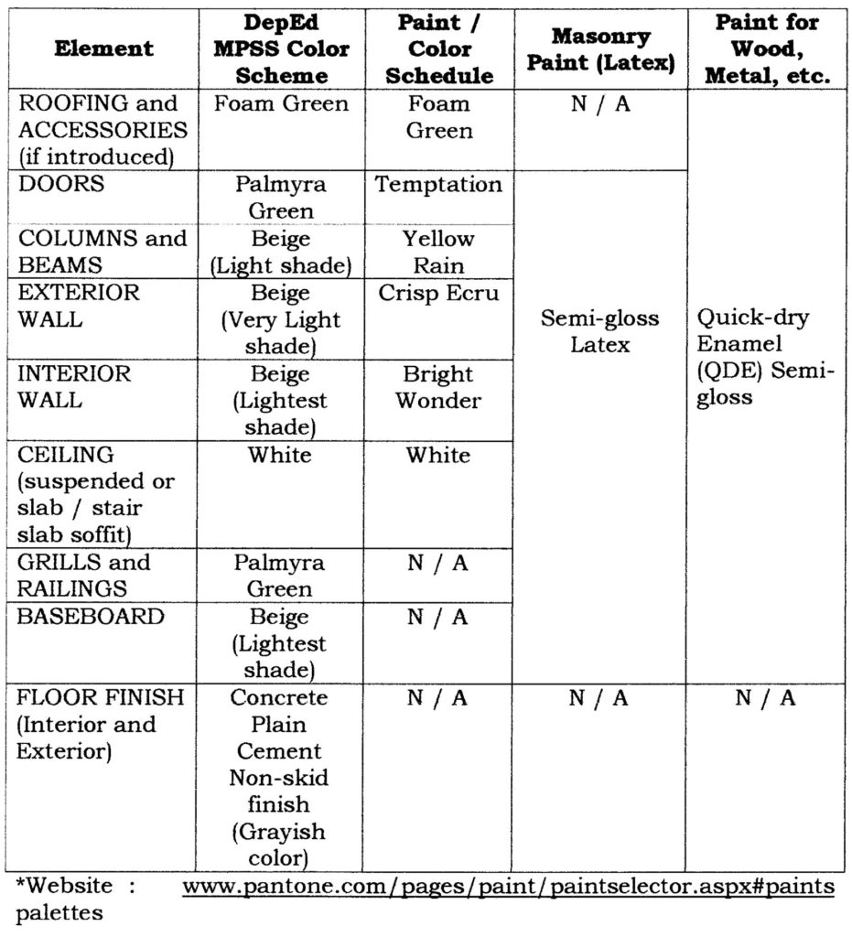

2) Paint materials for internal finish must be independently certified lead-safe paints/coatings.  
3) All new schoolbuildings should follow the standard color scheme above, except in the following cases:

i. A different dominant color scheme already exists. In such cases, the dominant color scheme may be applied.  
ii. Designs and/or accents depicting local culture or school approach are practiced. In such cases, the same design/accents may be adopted.  
iii. In both cases above, no additional cost may be charged.

4) No new design, accent, or color scheme different from what is hereby prescribed and/or from what already predominantly exists under Item 3 above may be proposed/introduced.

5) There is a need to ensure, as far as practicable, the uniformity of all public schoolbuildings essentially to provide an environment for educational activities, and effective teaching and learning. At the same time, the DepEd encourages and promotes regional diversity and cultural identity.

**m. Roof Markings**

MORE FROM TEACHERPH

[DEPED ORDER](https://www.teacherph.com/category/issuances/deped-order/)

[Early Language Literacy and Numeracy Program Funds](https://www.teacherph.com/early-language-literacy-and-numeracy-program-funds/)

May 23, 2018

[DEPED ORDER](https://www.teacherph.com/category/issuances/deped-order/)

[Promotion and Compensation of all ALS Implementers](https://www.teacherph.com/promotion-compensation-als-implementers/)

May 18, 2018

[DEPED ORDER](https://www.teacherph.com/category/issuances/deped-order/)

[DepEd School Calendar for School Year 2018-2019](https://www.teacherph.com/deped-school-calendar-2018-2019/)

May 16, 2018

[DEPED ORDER](https://www.teacherph.com/category/issuances/deped-order/)

[Flexible Working Hours of DepEd Non-Teaching Personnel](https://www.teacherph.com/deped-non-teaching-personnel-working-hours/)

May 11, 2018

Roof Markings shall be painted on the main building or the tallest building of the school. It shall include only the DepEd logo and School ID Number.

Details and specifications shall be as follows:

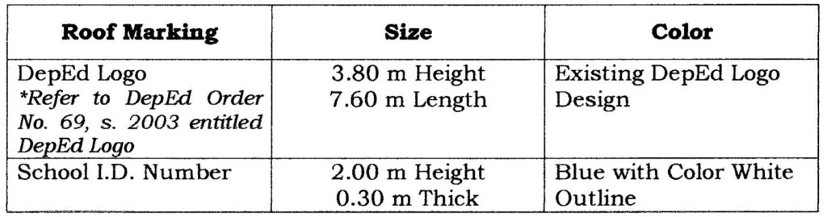

**Note:** Distance between the DepEd Logo and the School I.D Number shall be at least 2.00m  
n. Wall Markings

1) All walls must be free from any markings, except the following which may be painted on separate prominent places:

i. DepEd Name, Seal, Logo, Mission, Vision and Core Values  
ii. Portraits and Sayings of National Heroes  
iii. Name, ID, and Location of school.

2) An interior wall section may be selected and dedicated for the recognition of sponsors, donors, and other school partners, provided that the recognition material shall follow a standard metal plaque format that will be mounted on the wall.

**o. Ventilation**

Natural ventilation shall be primarily supplied by the windows and vents. Artificial ventilation inside each classroom shall be supplied by two (2) units of oscillating ceiling fans.

**p. Illumination**

Illumination falling at desk or arm rest should be taken with combined artificial and natural lighting. Illumination at all staircases and fire exit stairs shall comply with R.A. No. 9514 and its IRR.

VI. Structural Design Standards

a. The structural design must be in accordance with the revised IRR of the 1977 NBCP and the latest edition of the National Structural Code of the Philippines (NSCP), Volume 1, 2010.

**b. Classification of Structure**

In accordance with the NSCP, buildings under the Project shall be designed in accordance to the classification, based on the nature of occupancy, of “Essential Facilities.”

**c. Wind Load**

For all schoolbuildings, the roofing and walls shall be designed to withstand a minimum BASIC wind speed (as defined in Sec. 207 of the NSCP) of 250 kilometers per hour (kph). The year-round effects of the southwest monsoon (“habagat”) wind and the northeast monsoon (“amihan”) wind as well as of the easterly winds must be taken into consideration due to the extensive damage these may cause to roofing, walls, and fenestrations.

A Wind Importance Factor (WIF) of 1.15, based on the NSCP, shall be used.

The structure should be fully sealed against rainwater intrusion during typhoons and heavy rains to protect sensitive materials and equipment. Doors and windows should be fully sealed against strong vertical and lateral rains.

**d. Seismic Load**

For all schoolbuildings, the structure shall be designed to withstand earthquakes for Seismic Zone 4 with a corresponding Seismic Zone Factor of 0.4, or as otherwise specified in the NSCP.

A Seismic Importance Factor (SIF) of 1.5 shall be used.

As the FFL shall be elevated to 0.20 meter above the level of flood indicated/identified in the Site Appraisal Reports (SAR), the use of “containment wall” is prescribed to ensure the safety of the structure during the rainy season.

**e. Live Loads**

The minimum occupancy or live loads shown in the table below shall be used in the design.

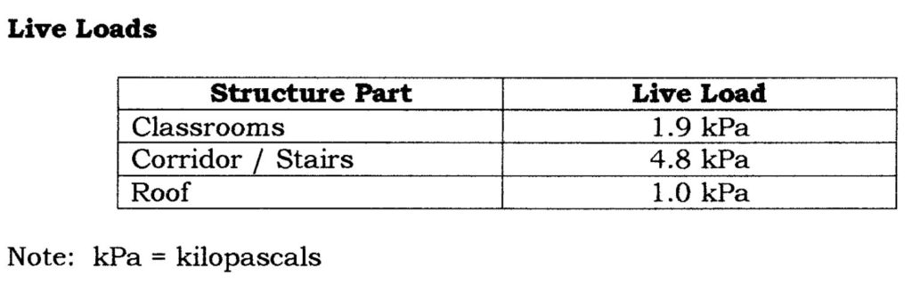

**f. Design Life**

The school building and its structure shall have a design life of at least twenty-five (25) years.

**g. Building Foundation**

The foundation shall be designed for a net allowable soil bearing pressure of 96 kPa (2,000 pounds per square foot or psf). Consistent with best practices, the Proponent shall undertake the prior appropriate studies/investigations for use as basis/bases for the foundation and structural design of each Sub-Project.

**h. Wall Vibration**

Walls must not unduly vibrate due to impact caused by any part of an adult human body and must neither be dented nor punctured by deliberate punches or kicks by adult humans.

VII. Electrical Design Standards

The electrical design must be in accordance with the latest edition of the Philippine Electrical Code (PEC). It must be provided with the basic electrical power and lighting layout, general notes, riser diagram, single line diagram, legends and symbols, load schedule and auxiliary layouts.

**a. Lighting and Fixtures**

1) Each classroom of dimension 7m x 9m or 9m x 7m must be provided with at least six (6) units of double T-5 36 watts fluorescent lamp with reflector or a minimum of 104 Lumens per Watt (LPW).  
2) A duplex convenience outlet (CO) of the grounding type must be provided on each windowless side of the classroom.  
3) Two ceiling outlets for ceiling fans for every classroom must be provided.

**b. Wires and Wiring Devices**

1) Wires shall be properly designed in accordance with Article 3.10 and the grounding system shall conform to Article 2.50 of the PEC.  
2) Wiring devices must be of modern type and approved for both location and purpose.  
3) Service Entrance wires for a standard 7m x 9m or 9m x 7m described above must have a size of 8.0 sq.mm minimum and properly protected by circuit breaker protection.

**c. Roughing-ins**

**Service Entrance**

The service entrance shall be at least 1.60 meters above the natural grade line (NGL) or 0.30 meter above the established high flood level, whichever is higher.

VIII. Sanitary and Plumbing Design Standards

**a. Provision of Toilets and Sanitary Facilities**  
Toilets and sanitary facilities shall be in accordance with the Plumbing Code and the Sanitary Code of the Philippines.

**b. Waste and Vent Line Piping System**  
The drain, waste, and vent line piping system must be aligned with the American Society for Testing and Materials (ASTM) D-2729, International Standards Organization (ISO) 4435 and ISO 3633.

**c. Waterline Piping System**  
The system must be aligned with the Deustche Industrie-Norm (DIN) 1988 for Polypropylene Random Copolymer (PP-R) type 3 pipe and ASTM A53/ A53M. The system must provide for a waterline service entrance.

**d. Plumbing Fixtures**  
These must be aligned with the American National Standards Institute (ANSI) / American Society of Mechanical Engineers (ASME), A112.19.4m, A112.19.3, A112.19.5.

**e. Drainage System**  
The storm drainage system must be sized in consideration of the rainfall intensities, slope, and roof areas of the schoolbuildings. Provision shall be made for the future installation of rainwater collection system in compliance with R.A. No. 6716 “An Act Providing for the Construction of Water Wells, Rainwater Collectors, Development of Springs and Rehabilitation of Existing Water Wells in all Barangays in the Philippines”.

**f. Septic Vault**  
All concrete septic tanks, if used as the sanitation solution, shall be protected from corrosion by coating with an approved bituminous coat or by other acceptable means.

IX. Mechanical / Fire Protection Design Standards

All Mechanical System equipment and installation mentioned shall conform to the provisions of the Mechanical Code of the Philippines, latest edition.

X. MONITORING AND EVALUATION

* Expected Outcome  
  Comfortable and safe school children in schoolbuildings turned over and accepted by DepEd from government or private implementers.
* Success Indicators  
  All schoolbuildings constructed are compliant with the Minimum Performance Standards and Specifications (MPSS) for schoolbuildings as mandated in this DepEd Order.
* Office in-Charge of M&E per governance level:

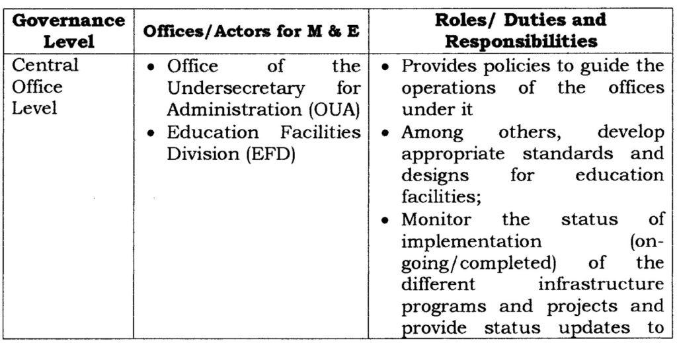

* Mechanics and Timetable for Progress Monitoring and Evaluation Based on the timetable submitted by the Project Implementor, DepEd Engineers (Regional, Division, and Project Engineers) shall coordinate and prepare schedule of visits to monitor schoolbuilding projects.
* Feedback Mechanisms  
  All feedback relayed to DepEd are referred to the office concerned for reply/action as necessary.

XI. REFERENCES

* Memorandum of Agreement (MOA) between the DepEd and DPWH On The Implementation of CY 2017 Basic Educational Facilities Fund (BEFF) dated March 20, 2017
* DepEd Order No. 69, series 2003 entitled DepEd Logo
* National Building Code of the Philippines (NBCP) and its revised Implementing Rules and Regulation (IRR)
* National Structural Code of the Philippines (NSCP), latest edition
* Philippine Electrical Code (PEC), latest edition
* Plumbing Code of the Philippines, latest edition
* Sanitary Code of the Philippines, latest edition
* Mechanical Code of the Philippines, latest edition
* Fire Code of the Philippines (R.A No. 9514) and its revised Implementing Rules and Regulation (IRR)